Query-> Sol-1

select MAX(e.salary) as [Number of people],d.dept_name from Employee e\

right join Department d on d.dept_id = e.dept_id

group by d.dept_name

order by COUNT(e.dept_id) desc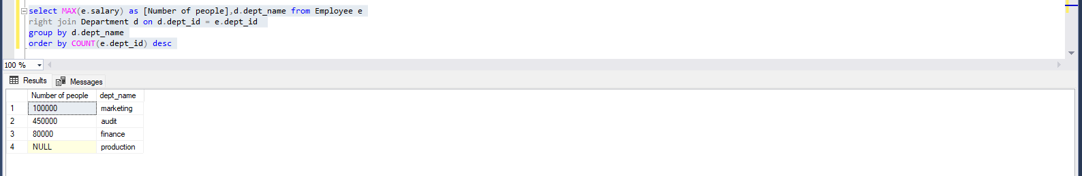

Query-> Sol-2

select COUNT(Employee.dept_id), Department.dept_id from Department

left join Employee on Employee.dept_id = Department.dept_id

group by Department.dept_id

having COUNT(Employee.dept_id) < 3

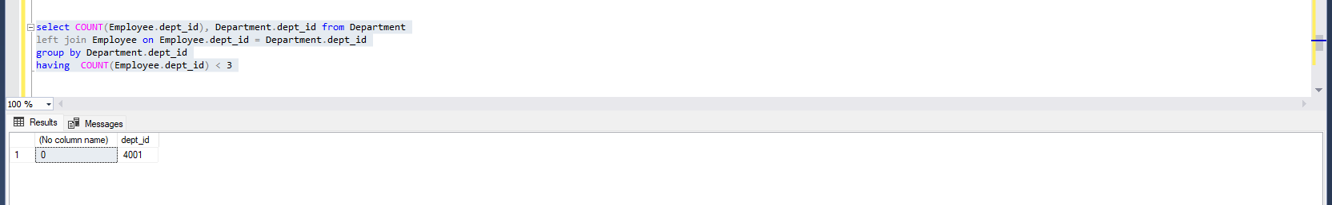

Query-> Sol-3

select COUNT(e.dept_id) as [Number of people],d.dept_name from Employee e

right join Department d on d.dept_id = e.dept_id

group by d.dept_name

order by COUNT(e.dept_id) desc

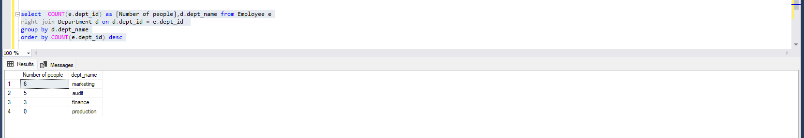

Query-> Sol-4

select d.dept_name,e.salary from Employee e

left join Department d on e.dept_id = d.dept_id

order by d.dept_name

